**DAILY ONLINE ACTIVITIES SUMMARY**

|  |  |  |  |  |  |  |  |
| --- | --- | --- | --- | --- | --- | --- | --- |
| **Date:** | **30-05-2020** | | | | **Name:** | **B.A.SOHANKUMAR** | |
| **Sem & Sec** | **4TH SEM A** | | | | **USN:** | **4AL18CS013** | |
| **Online Test Summary** | | | | | | | |
| **Subject** | | **1. DATA COMMUNICATION**  **2. COMPLEX ANALYSIS , PROBABILITY AND STATISTICAL METHOD** | | | | | |
| **Max. Marks** | | **1. 30**  **2. 30** | | **Score** | | **1. 27**  **2. 28** | |
| **Certification Course Summary** | | | | | | | |
| **Course** | **INTRODUCTION TO R** | | | | | | |
| **Certificate Provider** | | | **GREAT LEARNING ACADEMY** | **Duration** | | | **2.5 HOURS** |
| **Coding Challenges** | | | | | | | |
| **Problem Statement:1: Write and a C program to count Uppercase,Lowercase, special characters and numeric values for a given String.** | | | | | | | |
| **Status: EXECUTED** | | | | | | | |
| **Uploaded the report in Github** | | | | **YES** | | | |
| **If yes Repository name** | | | | **LOCKDOWN CODING** | | | |
| **Uploaded the report in slack** | | | | **YES** | | | |

**ONLINE TEST DETAILS:**

1. The test was from 3rd and 4th module of DATA COMMUNICATION (18CS46).The time duration was 40 minutes from 09.15 am to 10.00 am.There were 30 questions of mcq type.score I received is 27/30.

2. The test was from 3rd module of COMPLEX ANALYSIS , PROBABILITY AND STATISTICAL METHOD.The duration of the test was 40minutes from 03.00pm to 03.40pm.There were two rounds in online test.First round of 10 mcq of 1 marks each and second round was 10 mcq of 2marks each.

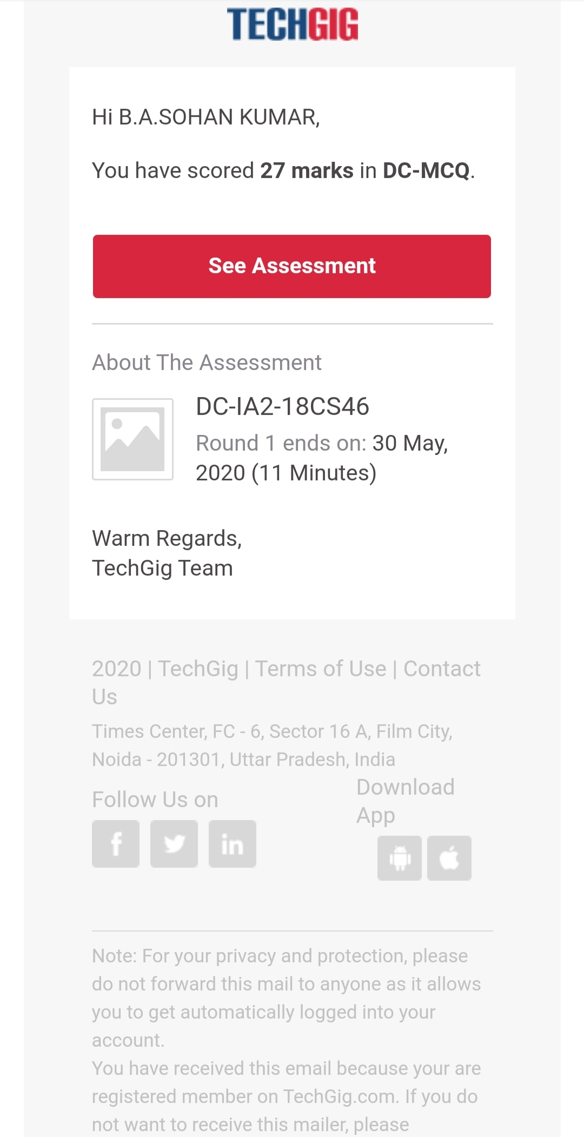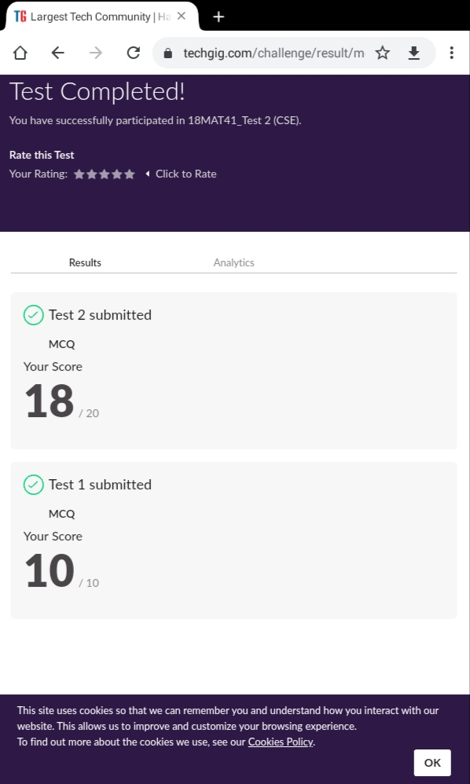

SNAPSHOT:DATA COMMUNICATION SNAPSHOT:MATHS

**CERTIFICATION COURSE DETAILS:**

**Course: INTRODUCTION TO R**

Today I learnt about Measures of Centrality,Measures of Dispersion,Visualizing Data,Data in R.And completed the quiz 2.

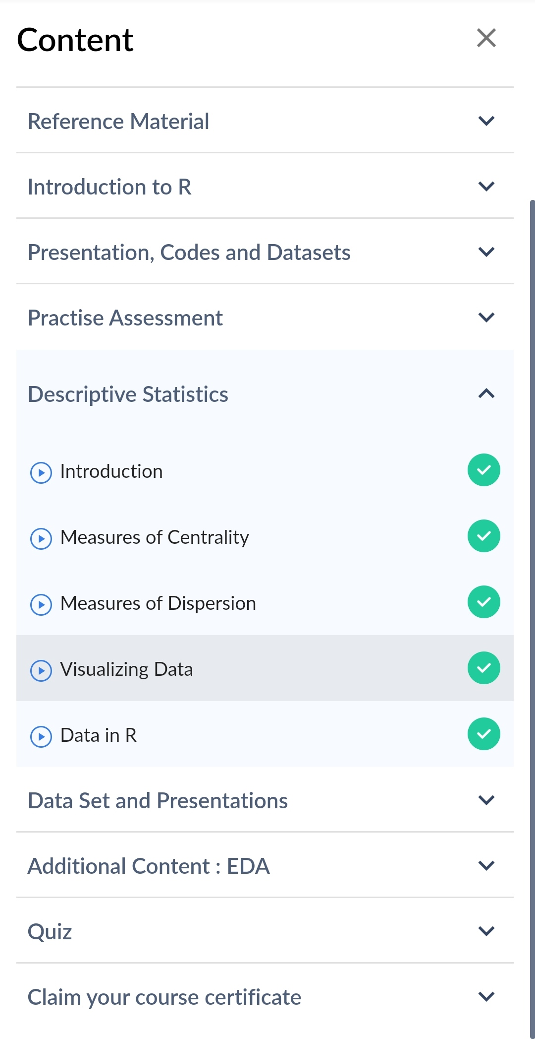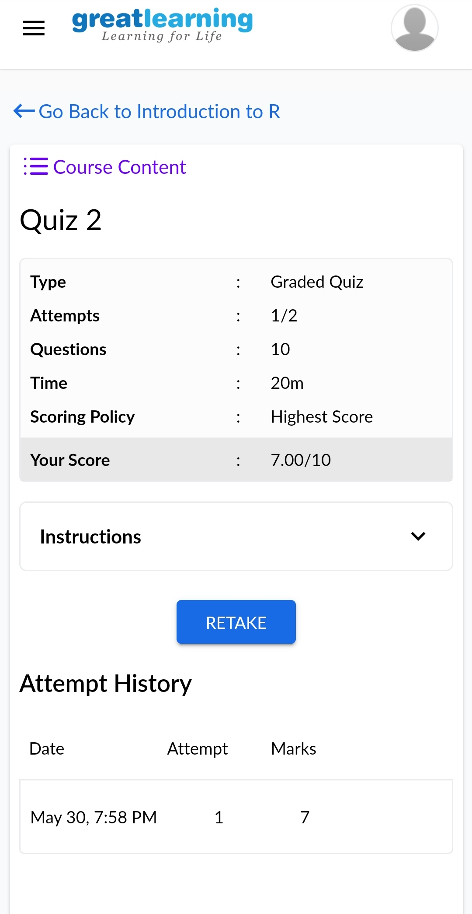

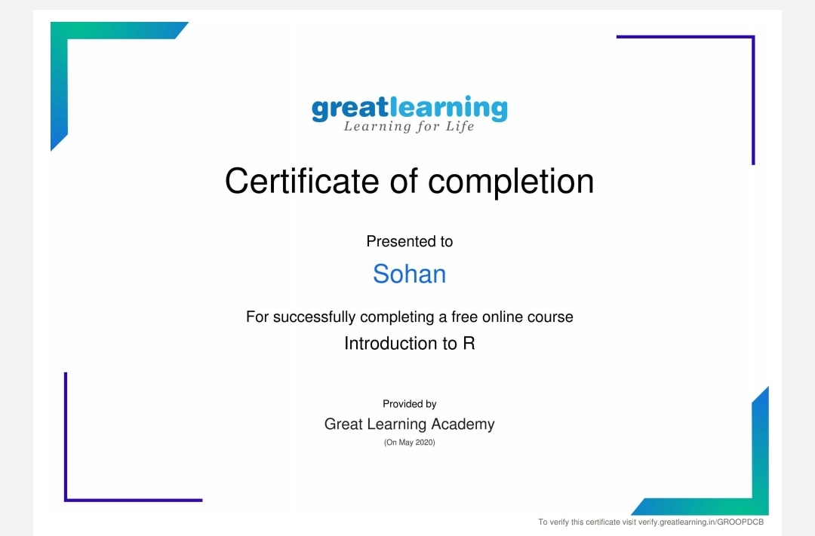

The above certificate is issued by great learning academy for the completion of the Introduction to R certification course.

**CODING CHALLENGES:**

1.Write and a C program to count Uppercase,Lowercase, special characters and numeric values for a given String.

Input : Read a String (combination of character, numeric, special character) from keyboard.Ex: #HaaGs01fOr@haaks07Output :Upper case letters : 5 , Lower case letters : 8, Numbers : 4,Special Characters : 2

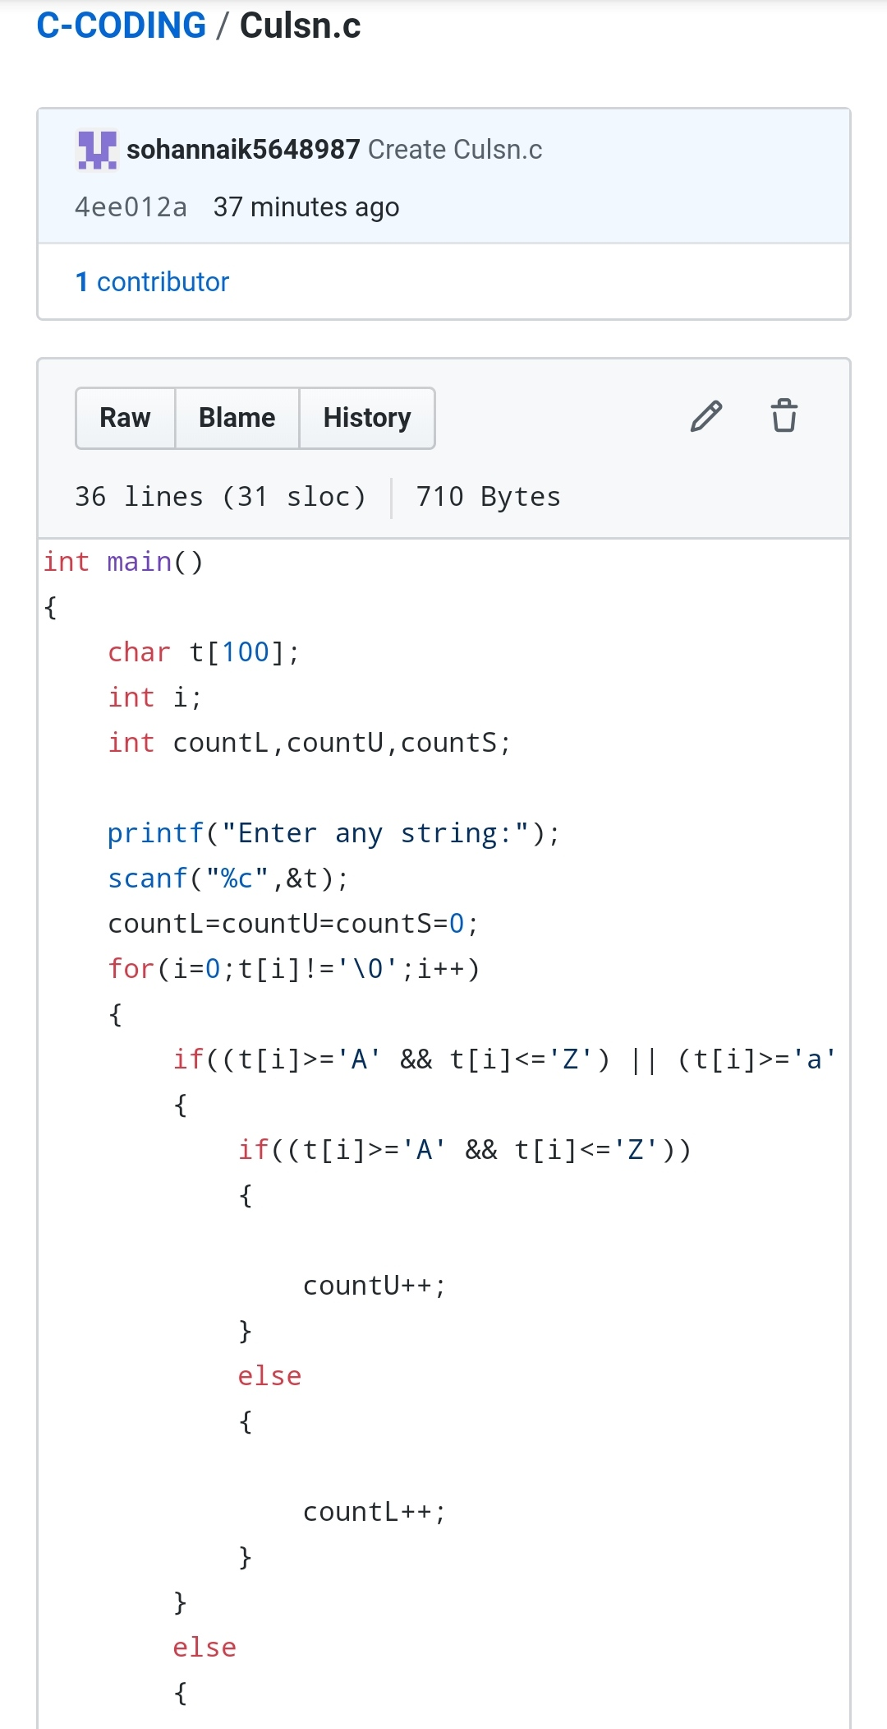

REPOSITORY LINK:https://github.com/sohannaik5648987/C-CODING